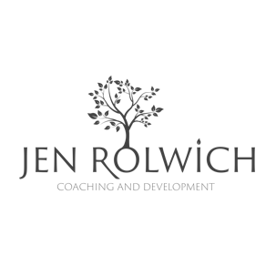
Unstoppable Vision – Creating your vision statement

Think of a time in your life where you felt like you belonged or were making a valuable contribution, what was good about it?
What did you contribute that gave you a sense of belonging?
Which of your basic needs were being met?
Which of your values were being honoured?

What works really well in your life that you want in your future?
What do you need to do to attain, nurture and develop this?

When are you at your absolute best?

What makes this happen?

When are you at your absolute worst?
What makes this happen?
What do you implement to get you back to your best?

What sharpens your saw?
What is the thing that you could talk about all day every day?
What’s the thing that’s just for you, that doesn’t contribute
to a role or have a purpose other than enjoyment?
If you can’t think of anything, what will you do to find out
the answer to that question?

What are you really good at?

This can be something you’ve learned or a natural talent or gift.
How does it feel when you do it?

1.

2.

3.

Think about 3 people you admire;
What are the qualities or traits you admire most in these people?
Do you share any of these with them?

If you had unlimited time and resources
What would you do?

What do you consider your most important contribution
to the world to be?
What’s the legacy you want to leave behind?

Role | Key Person | What they value/expect
Think about the different roles you play in your life;
What do these people value most about you?
What do they expect from you?
Who’s in your boardroom of trusted people to take advice from?

In 10 years’ time, what do you want your boardroom to say about you?
What would you like the key people in each of your roles to say?

What 3 things can you do in each of these roles to make this a reality?

Role | Key Person | 3 things I can do in this role to improve

My mission in life is to:

In my roles as _____________ I will:

I will consistently honour my hierarchy of values which are:

In the next 5 years, to get closer to my vision I will:

To be the best possible version of me, I will always put myself first by:

I will choose happiness and fulfilment by always making time for:

I will know what my success looks like when I;

See:

Hear:

Feel:

When I reflect on my life I want to know that I:

My most important contribution to the world and those around me will be:

I will know I am not living by my values and highest purpose when _____________ and when this happens I will ____________________ to realign myself to my own journey

I will surround myself with people who inspire me and possess the attributes and qualities I admire of:

The basic needs I must have met for true fulfilment are:

Physical:
Spiritual:
Mental:
Social:
Emotional:

Put this in a format that makes most sense to you, whether it be paragraphs, one statement or a vision board. The only rule is that when you read/see it, it must inspire you to achieve your goals and push yourself to fulfil the life that you truly want.

